PURCHASE ORDER NOTES BY VENDOR or ITEM

To have notes transfer from the vendor file to every new purchase order, there are a few simply steps.

Client Question

How do I get notes to print on a Purchase Order?

ASI Response

First, not all purchase order formats have been programmed for all notes.
Both raw goods and finished goods may be purchased.
The answer is the same for both items, however where to ADD is different.
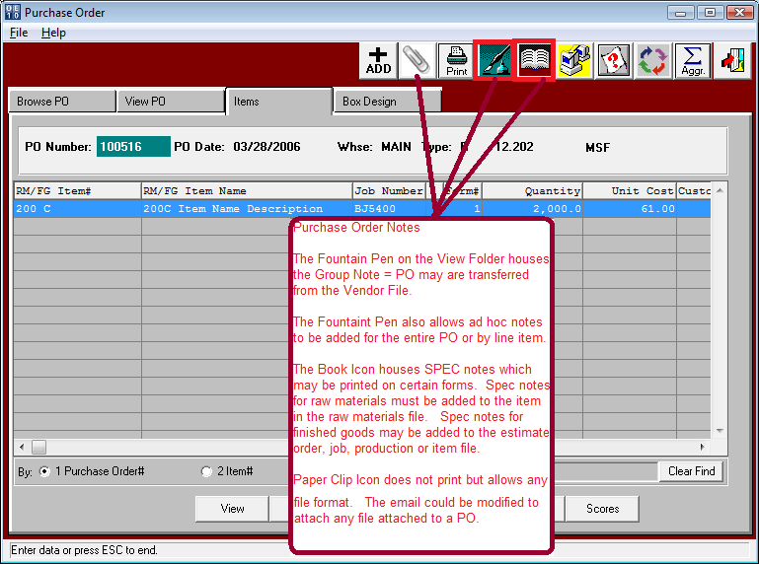
- The Fountain Pen on the purchase order View and Item folders allow notes just for that PO.
The VIEW folder fountain pen is for the entire PO.
The ITEM folder fountain pen is for the line item only.
- The Fountain Pen also houses the Group Note = PO, which must be added under N-C
Once the Group note exists, standard notes may be added to the vendor file.
Group notes will transfer to every purchase order for this vendor.

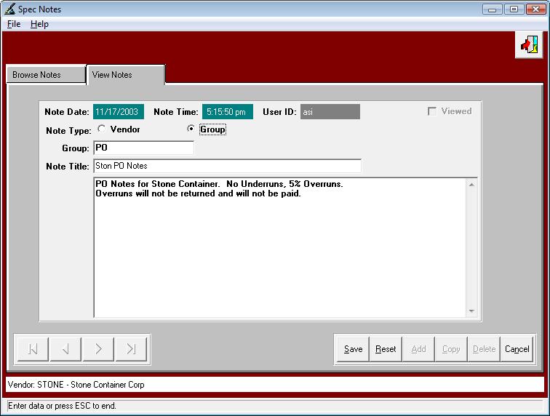

- The BOOK ICON houses SPEC Notes.
Spec Notes must first be added to the N-Z-6 file.
Spec notes will print on certain job tickets as well as certain purchase order forms.
Of course we can modify any form to add the spec notes or only specific spec notes.
The N-K-1 POPrint = Xprint and Southpak have the ability to print Spec Notes.
Spec notes are notes added to a raw material or finished goods item.
Raw materials spec codes must be added to the M-F-1 file.
Finished goods spec codes may be added to the I-F-1, estimate, order, job or production screens.

- PAPER CLIP ICON Currently do not print on any form.
However we could very easily add the files as attachments to a email for the PO.

- Lastly, certain forms such as the N-K-POPrint = FIBREX can print electronic signatures.
The BUYER listed on the PO Header will print a signature from the RCODE/Signature file with the same name. This must be a .JPG signature.

